

**M.V.P. SAMAJ’S**

**K.R. T ARTS, A.M. SCIENCE AND B.H. COMMERCE**

**COLLEGE, GANGAPUR ROAD**

**NASHIK.**

**A PROJECT REPORT**

**ON**

**Student’s Space**

**Developed by**

**Shimpi Apurva**

**Govardhane Nitin**

**B.C.A. (Science)**

**(2022-2023)**

Under the guidance of

**Prof./Dr. Sucheta Borse**

SAVITRIBAI PHULE PUNE UNIVERSITY



M.V.P SAMAJ’S

**KRT Arts, BH Commerce and AM Science College, Nashik**

**CERTIFICATE**

This is to certify that Mr./Miss. **__________________________, (**Seat No :**_________ ),** Mr./Miss. **______________________, (**SeatNo :**________ ) &** Mr./Miss. **_______________________ (**SeatNo :**_________ )** of T.Y.B.C.A (Science) have / has successfully completed project titled **______________________** satisfactorily as partial fulfillment of curriculum for T.Y.B.C.A.(Science) Semester-VI during academic year 2022-2023.

**Project Guide Head,**

**Dept. of Computer Science**

**Internal Examiner External Examiner**

Acknowledgement

We are happy to present the project *“Student’s Space”* in PHP.

Our project *“Student’s Space*” would not have been completed without the valuable guidance and encouragement of Mrs. Borse ma’am and all staff members.

I also want to express my sincere thanks to all the individuals who have contributed to this project in various ways. Whether it was by offering their time, expertise, resources, or simply providing a listening ear, each person played a crucial role in bringing this project to fruition. Your support has been invaluable and deeply appreciated.

Your mentorship and leadership have been critical in helping us to navigate the complexities of this undertaking. Once again, I am grateful for the contributions of everyone involvement in our project.

Govardhane Nitin

Shimpi Apurva

INDEX

|  |  |  |
| --- | --- | --- |
| **Sr.No** | **Title** | **Page NO.** |
|  | Introduction |  |
|  | Problem Statement & Definition. |  |
|  | Objectives of goals |  |
|  | Project Scope |  |
|  | Feasibility study. |  |
|  | H/w and s/w requirement |  |
|  | ERD |  |
|  | DFD |  |
|  | Data Dictionary. |  |
|  | Sample I/O Screen. |  |
|  | Limitation |  |
|  | Conclusion |  |
|  | Advantages |  |
|  | Bibliography |  |

|  |
| --- |
|  |

INTRODUCTION

* **Student Space** is a web platform designed to provide students of the BCA Science department with study notes, assignments solutions, and career guidance in programming.
* Our website aims to simplify the academic journey of students by providing them with valuable resources in one convenient location.
* In addition to our core features, we also offer a community section where users can submit their own content, share their experiences, and engage with other students.
* Our platform is built using modern web technologies such as PHP, HTML, CSS, and JavaScript, and we are constantly striving to improve and expand our services to better meet the needs of our users.

Problem definition

We are providing website “Student’s Space”. As the name suggest it is represented for academic students.

There are must be available another source for student but we have designed this website specially for the BCA students with all subjects notes and year wise assignments solution which are not particularly available on other websites.

We included paid as well as free courses related to programming language which needed for computer science. As the user visit our website, we suggest lots of courses according to the year of graduation of student. Like which course they should enroll first.

After the enrollment of any course, they can access notes of respective programming language and also, we are providing them live interaction for solving their query related to the course.

Other than that, we are sharing all assignments solution which will be undertaken in BCA course.

Student get all in one package whatever needed for completing BCA course.

OBJECTIVES of Project

The main objectives of Student Space are to provide students of the BCA Science department with a one-stop solution for all their academic needs. Our project aims to accomplish the following objectives:

* Provide students with easy access to study notes, assignments solutions, and career guidance in programming.
* Create a community platform for students to share their own content, engage with other students, and gain valuable insights and advice.
* Simplify the academic journey of students by providing them with all necessary resources in one convenient location.
* Use modern web technologies such as PHP, HTML, CSS, and JavaScript to build a robust and user-friendly platform.
* Continuously improve and expand our services to better meet the needs of our users.
* Overall, our project aims to help students succeed academically and professionally by providing them with the necessary tools and resources to excel in their studies and career.

Project scope

The proposed system will consist of the following modules:

* Courses Module: This module provides paid as well as free courses for student which are necessary to learn programming language. After enrollment of course student will get related notes and live interaction with mentor.
* Notes Module: This module will provide students with access to study notes depends on which course they have enroll.
* Assignments Module: This module will provide students with solutions to various assignments and projects related to computer science.
* Community Module: This module will allow students to submit their own content, engage with other students, and gain valuable insights and advice.
* Content Management System: This module will enable the website administrator to manage the content of the website including adding, editing, and deleting content.

The proposed system will be user-friendly, responsive, and easily accessible to students. It will simplify the academic journey of students by providing them with all necessary resources in one convenient location. The system will also be scalable and flexible to accommodate future expansion and improvements. Overall, the proposed system will be a valuable tool for students of the Computer Science department to excel in their studies and career.

Feasibility Study

An important outcome of preliminary investigation is the determination that the requested system is feasible for organization or not.

There are three aspects of Feasibility Study are as follows:

**1. Operational Feasibility: -**

The present system is easily understandable to the users are which is having user friendly interface that helps them to understand the flow of the system more easily. Maximum Transparency has been provided. The system provides for student academic success. The proposed project is beneficial specially for BCA student. website is directly used by the users and needs no other reference while accessing to our website. So, the website is operationally feasible.

**2. Technical Feasibility: -**

Technically needed hardware and software are available on our system to develop this project. Such as Windows 10, server needed to run project on our system. Overall, we have all things needed to develop this “Student’s Space” website. So, the website is technically feasible.

**3. Economical Feasibility: -**

The presence of hardware, software and various technical equipment’s reduced our cost as compared to the total work of our project. Hence the system being economically feasible.

Hardware/Software Requirements

Hardware Requirements:

* Processor: Intel Core i5 or higher
* RAM: 8GB or higher
* Hard Disk: 500GB or higher
* Monitor: 17" or larger, 1024x768 resolution or higher
* Keyboard and Mouse

Software Requirements

* Operating System: Windows 10
* Web Server: Apache 2.4 or Nginx 1.19 or higher
* Database Server: MySQL 8.0 or MariaDB 10.5 or higher
* PHP Version: PHP 7.4 or higher
* Code Editor: Sublime Text or any other preferred editor
* Browser: Google Chrome or Firefox or Safari

ER-DIAGRAM

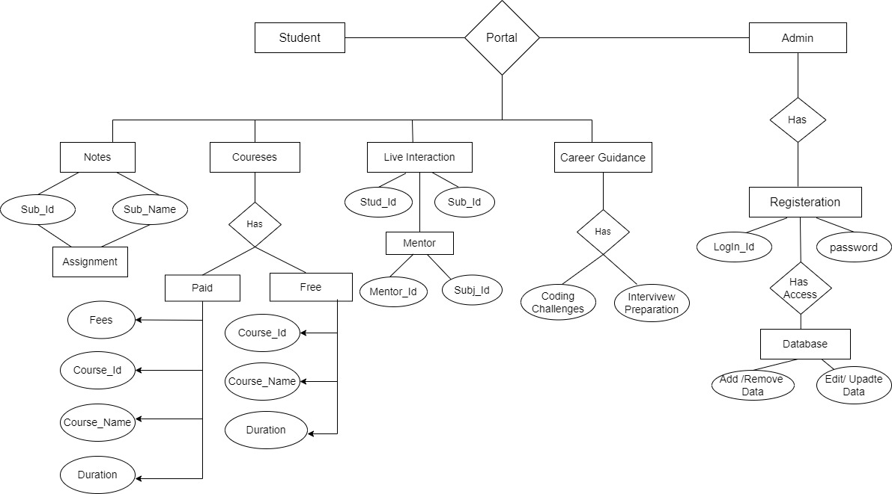

DFD-DIAGRAM

***Context Level DFD***

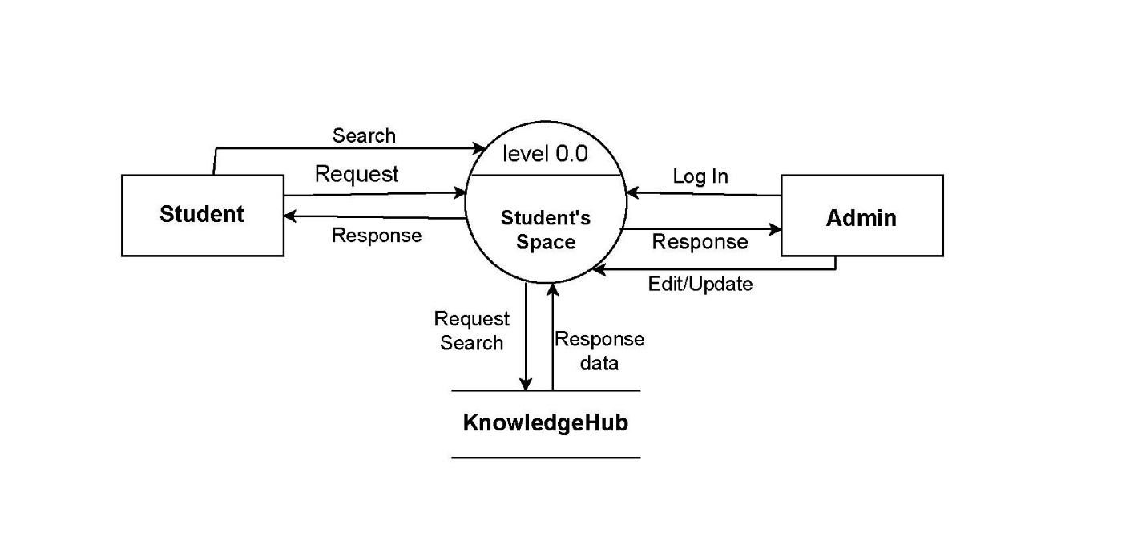

***First Level DFD :***

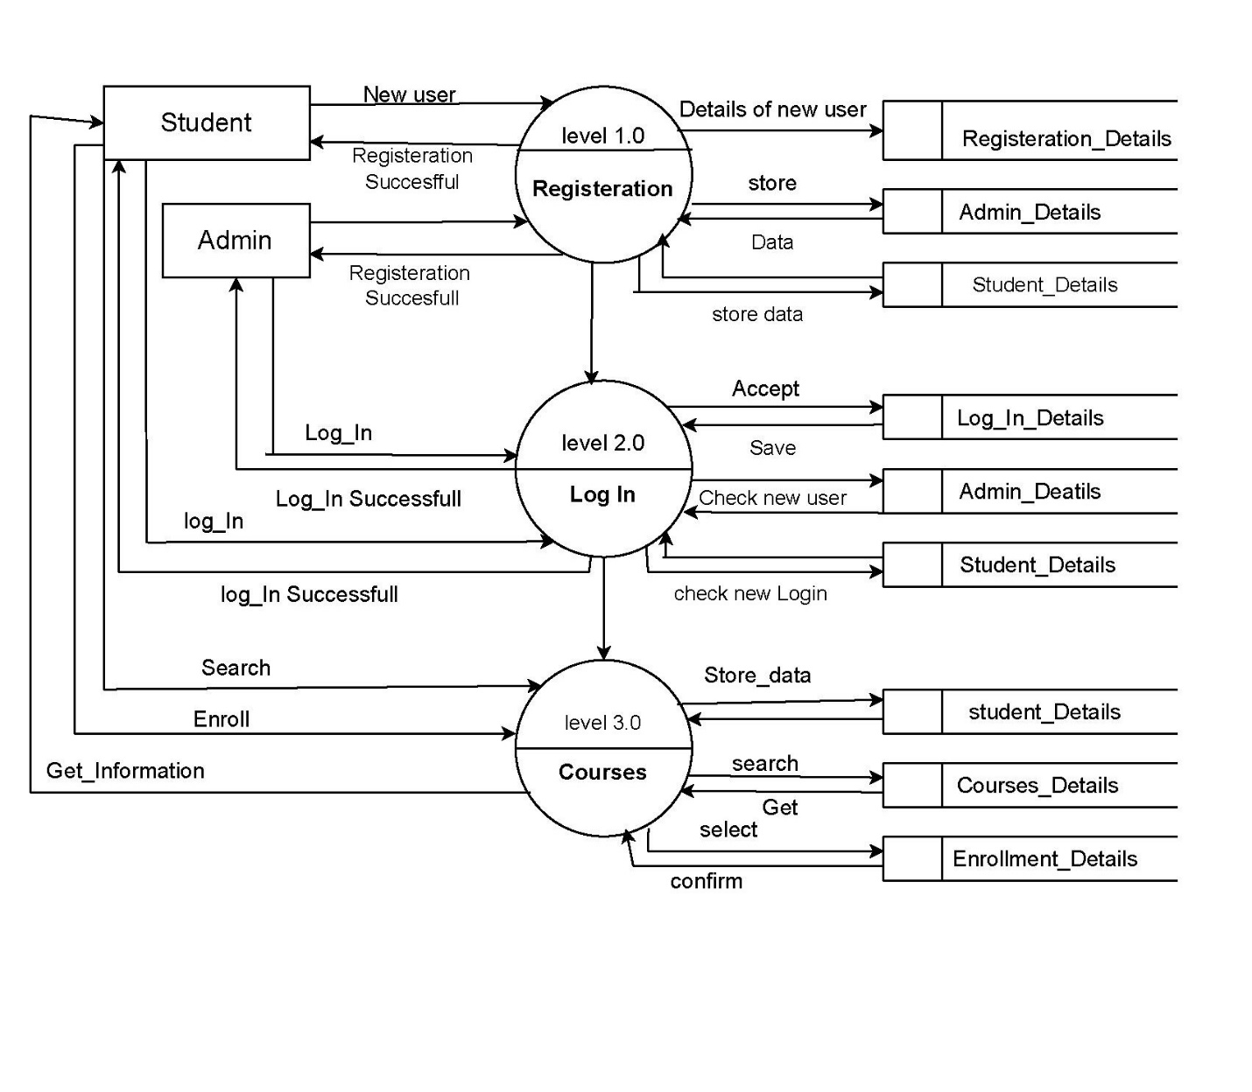

***Second Level DFD :***

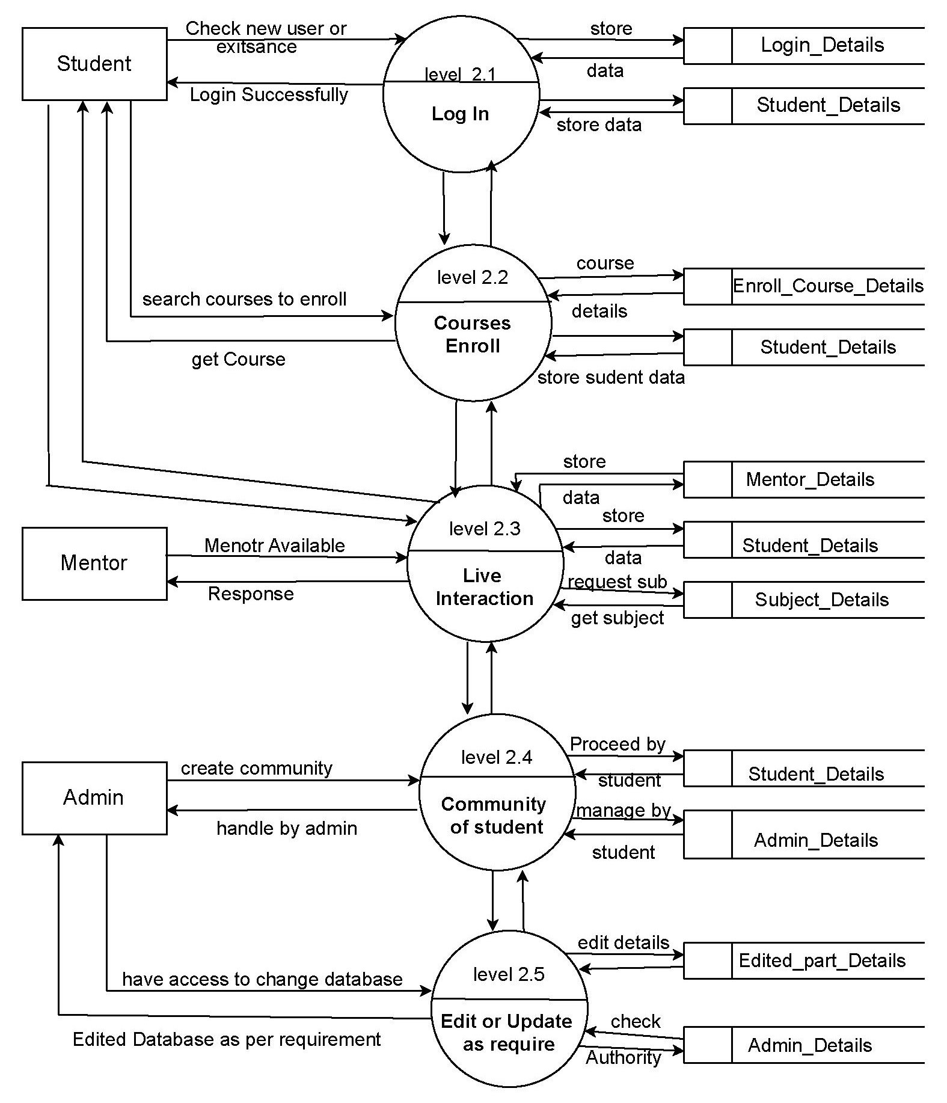

**Data Dictionary**

**Tbladmin:**

|  |  |  |  |  |
| --- | --- | --- | --- | --- |
| **Column** | **Type** | **Null** | **Key** | **Length** |
| adminid | int | No | Primary | 11 |
| username | varchar | No |  | 50 |
| password | varchar | No |  | 50 |

## Tbluser:

|  |  |  |  |  |
| --- | --- | --- | --- | --- |
| **Column** | **Type** | **Null** | **Key** | **Length** |
| uid | int | No | Primary | 11 |
| ufname | varchar | No |  | 50 |
| ulname | varchar | No |  | 50 |
| email | varchar | No |  | 50 |
| password | varchar | No |  | 20 |

**Tblclass:**

|  |  |  |  |  |
| --- | --- | --- | --- | --- |
| **Column** | **Type** | **Null** | **key** | **Length** |
| cid | Int | No | primary | 11 |
| cname | varchar | No |  | 50 |

**tblcourse**

|  |  |  |  |  |
| --- | --- | --- | --- | --- |
| **Column** | **Type** | **Null** | **Key** | **Length** |
| courseid | int | No | Primary | 11 |
| coursename | varchar | No |  | 50 |
| courseprice | float | No |  | 10,2 |
| coursedprice | float | No |  | 10,2 |
| courselink | text | No |  |  |
| coursedesc | text | No |  |  |
| courseimage | text | No |  |  |
| cid | int | No | Foreign key | 11 |

**tblcart**

|  |  |  |  |  |
| --- | --- | --- | --- | --- |
| **Column** | **Type** | **Null** | **Key** | **Length** |
| cartid | int | No | primary | 11 |
| uid | int | No | Foreign key | 11 |
| courseid | int | No |  | 11 |
| pmethod | varchar | No |  | 50 |
| ddate | text | No |  |  |
| ttime | text | No |  |  |
| status | int | No |  | 11 |
| year | int | No |  | 11 |

**tblnotes**

|  |  |  |  |  |
| --- | --- | --- | --- | --- |
| **Column** | **Type** | **Null** | **key** | **Length** |
| notesid | int | No | primary | 11 |
| pdffile | text | No |  |  |
| courseid | int | No | Foreign key | 11 |

**tblcontact**

|  |  |  |  |  |
| --- | --- | --- | --- | --- |
| **Column** | **Type** | **Null** | **key** | **Length** |
| Id | int | No | primary | 11 |
| uname | varchar | No |  | 50 |
| email | varchar | No |  | 50 |
| subject | varchar | No |  | 50 |
| message | text | No |  |  |
| uid | int | No | Foreign key | 11 |

**tblassignments**

|  |  |  |  |  |
| --- | --- | --- | --- | --- |
| **Column** | **Type** | **Null** | **Key** | **Length** |
| solutionsid | int | No | Primary | 11 |
| sclassname | varchar | No |  | 200 |
| ssubname | varchar | No |  | 200 |
| solutions | text | No |  |  |

Input-out screens

**Home Screen:**

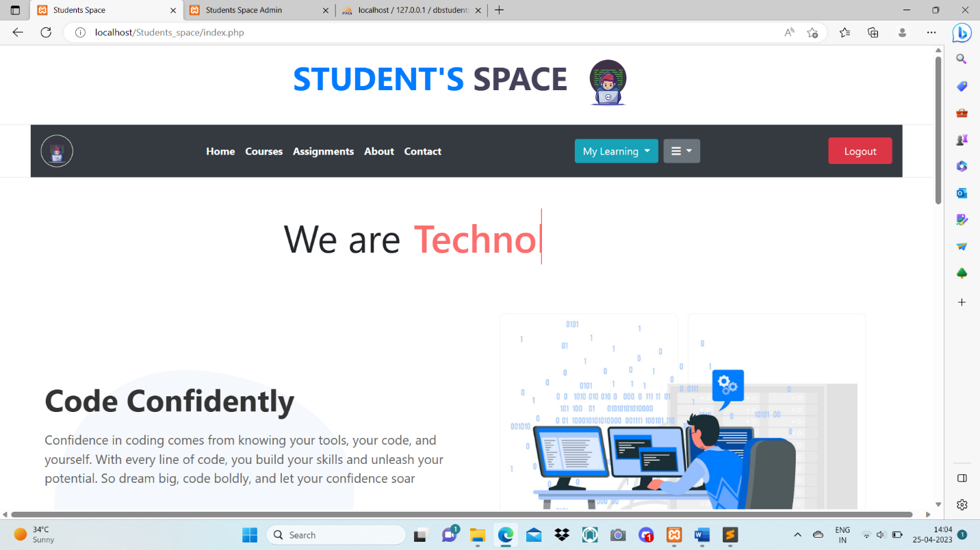

**User Registration:**

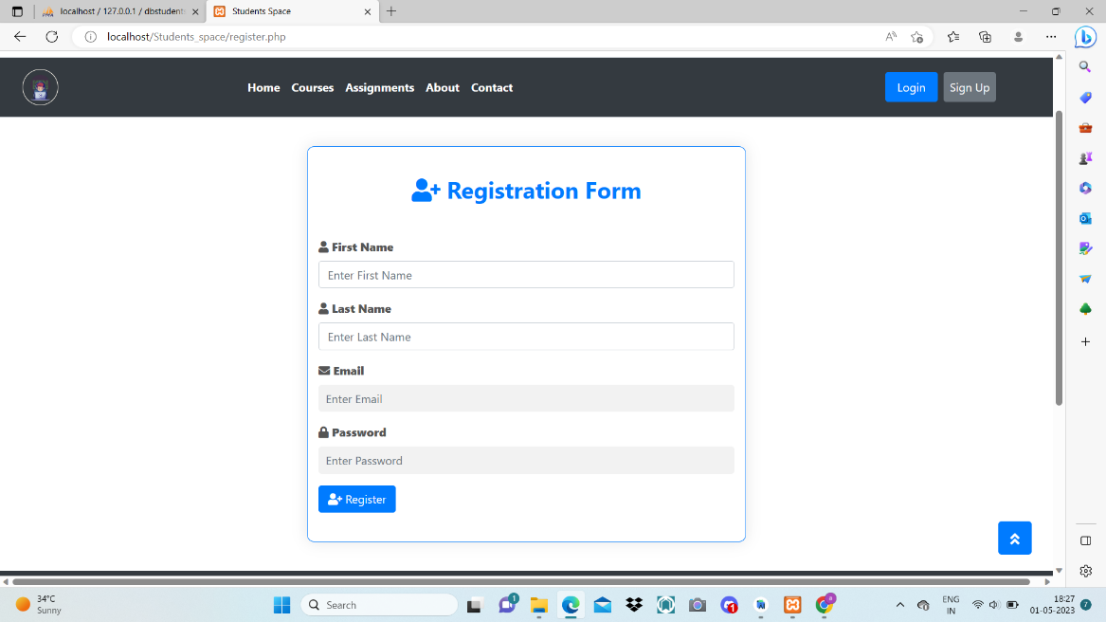

**User Login:**

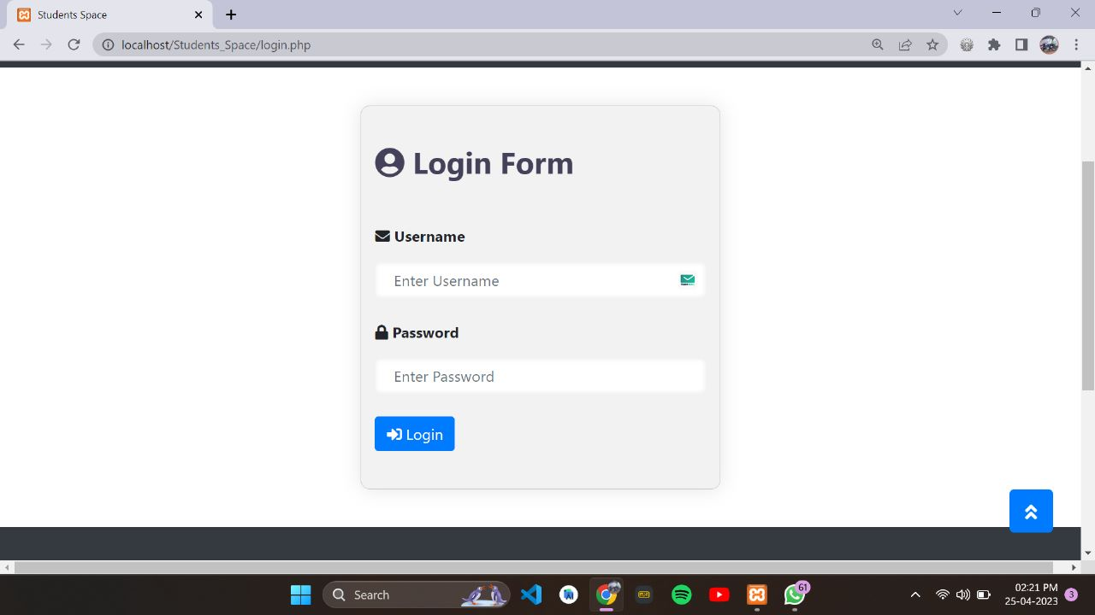

**Check credentials:**

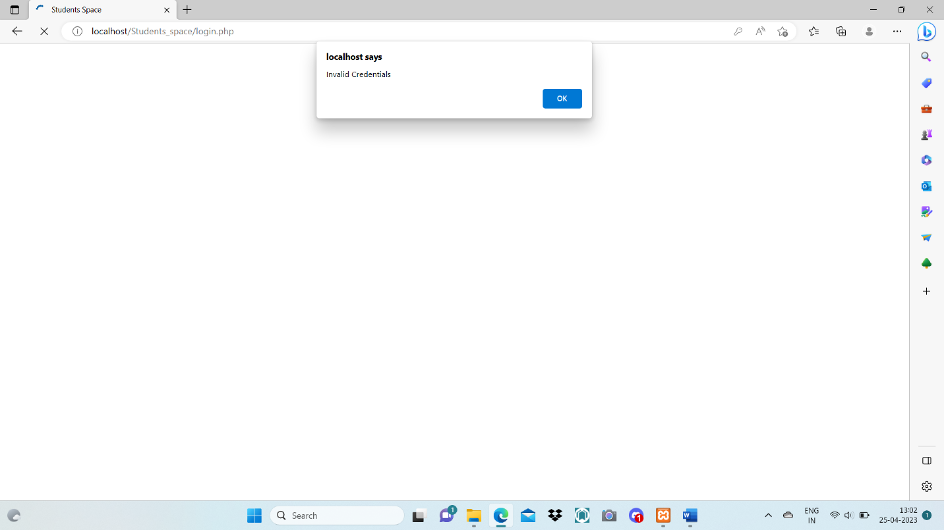

**Login Successful:**

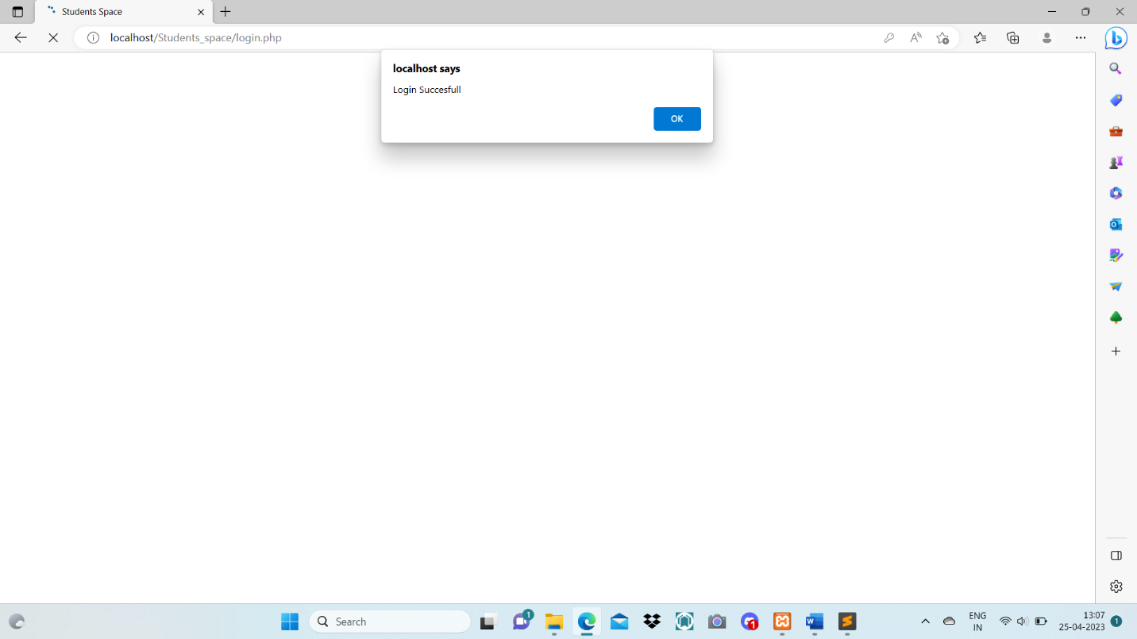

**View Courses:**

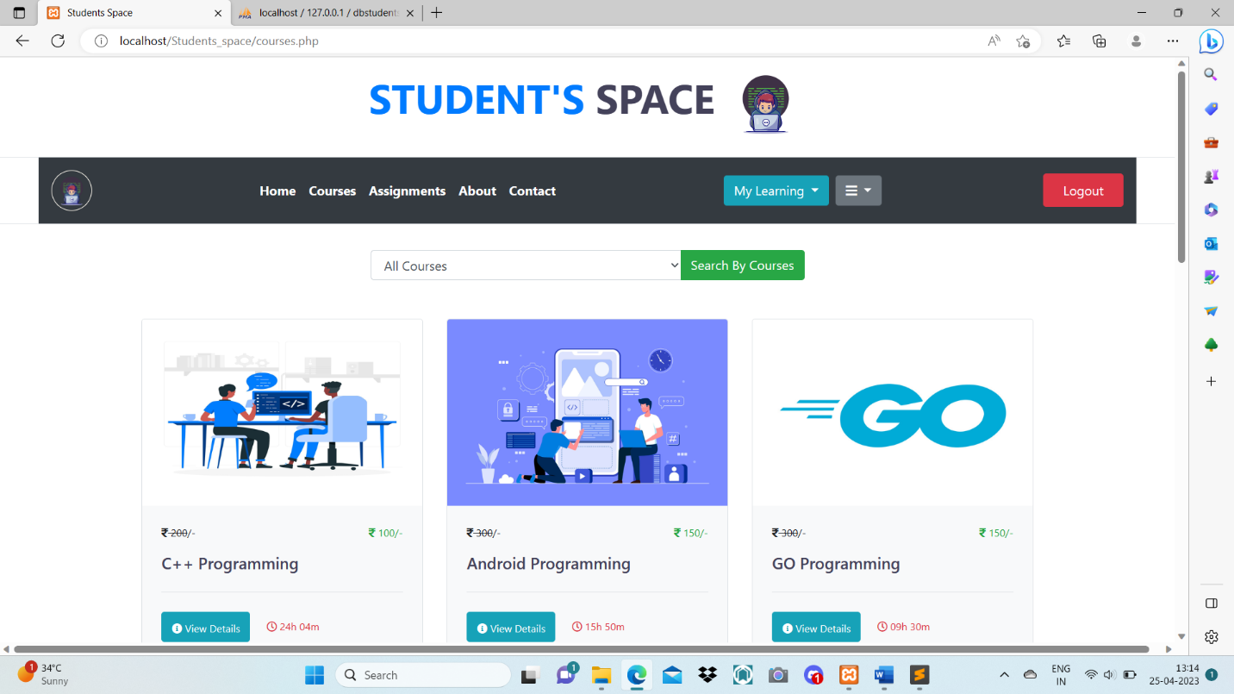

**View Details:**

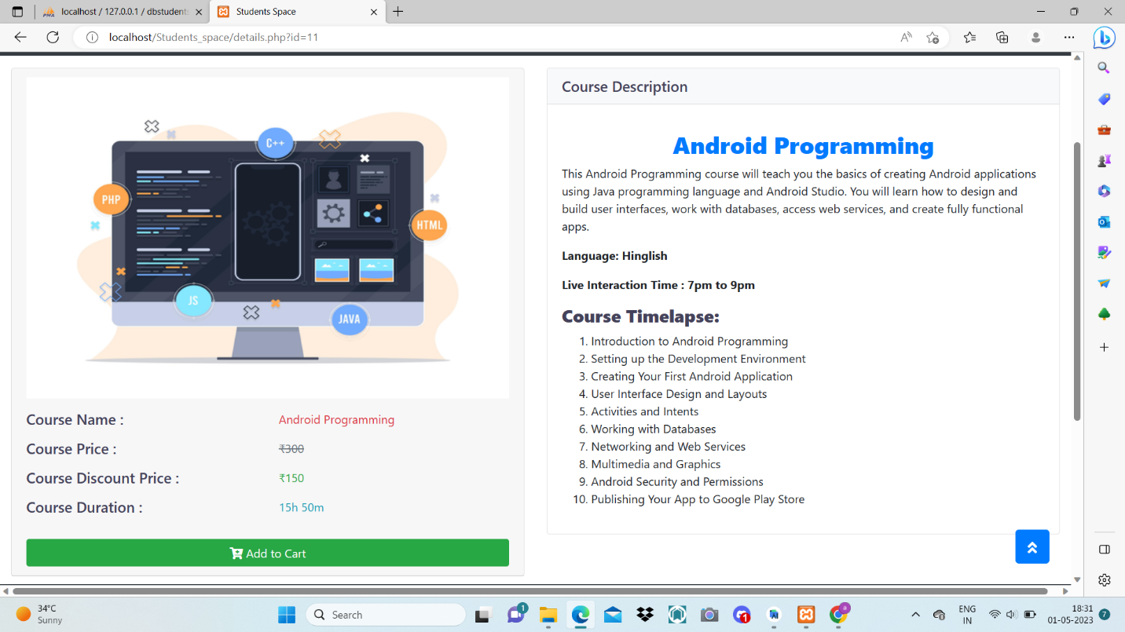

**View Cart:**

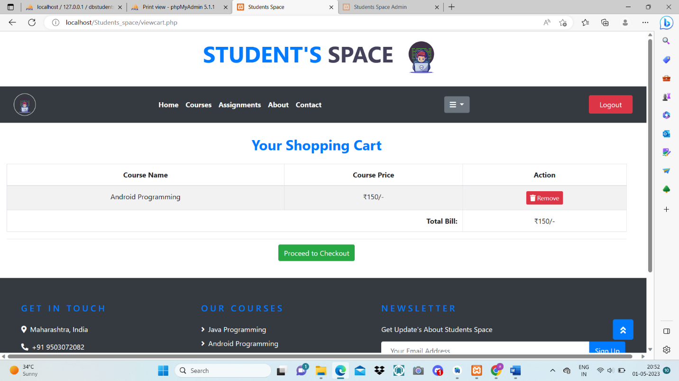

**User Order’s:**

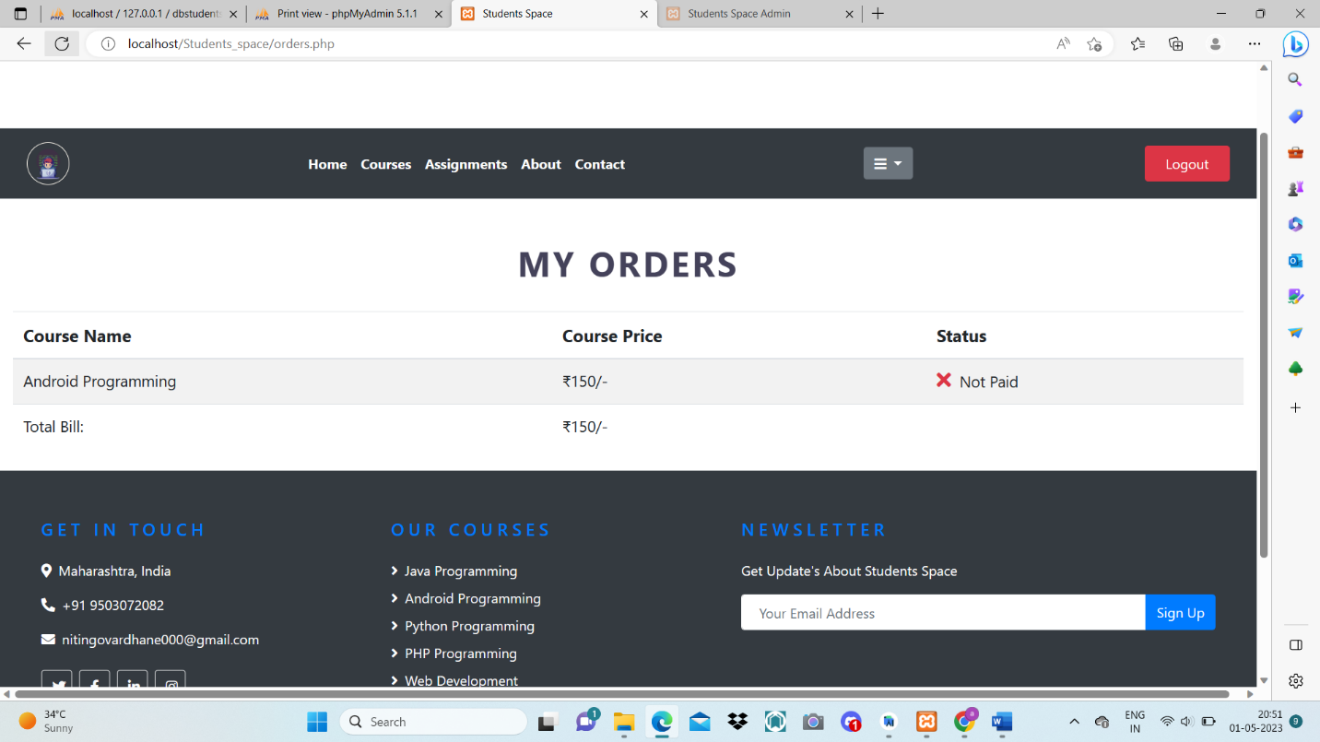

**Generate Invoice:**

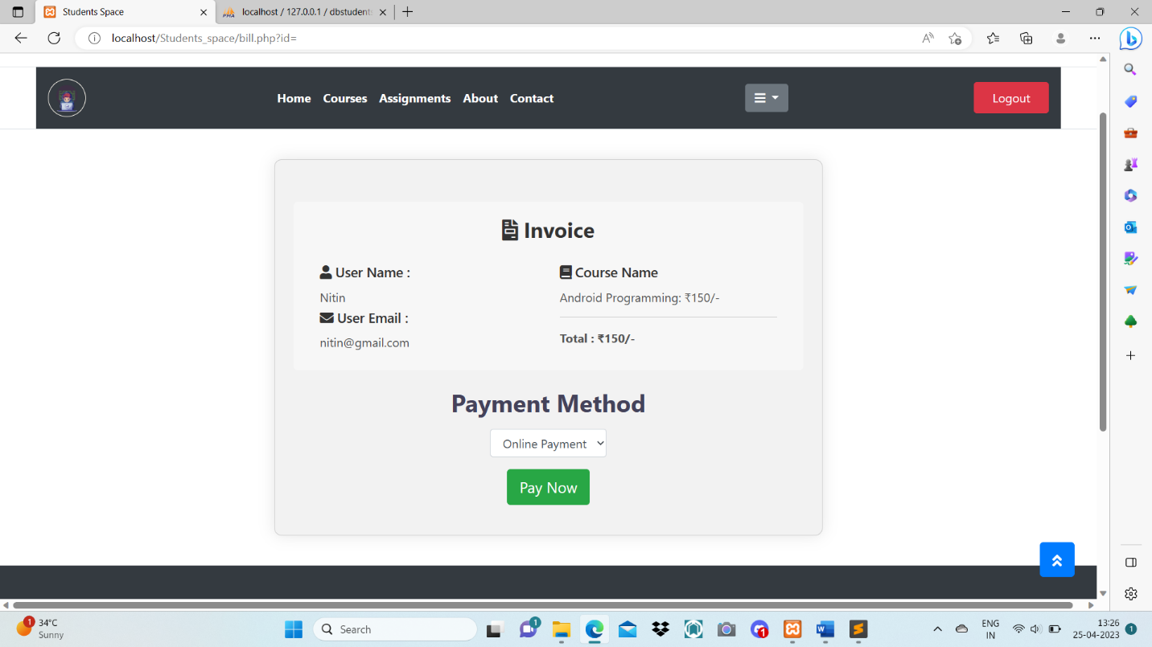

**Manage order by Admin:**

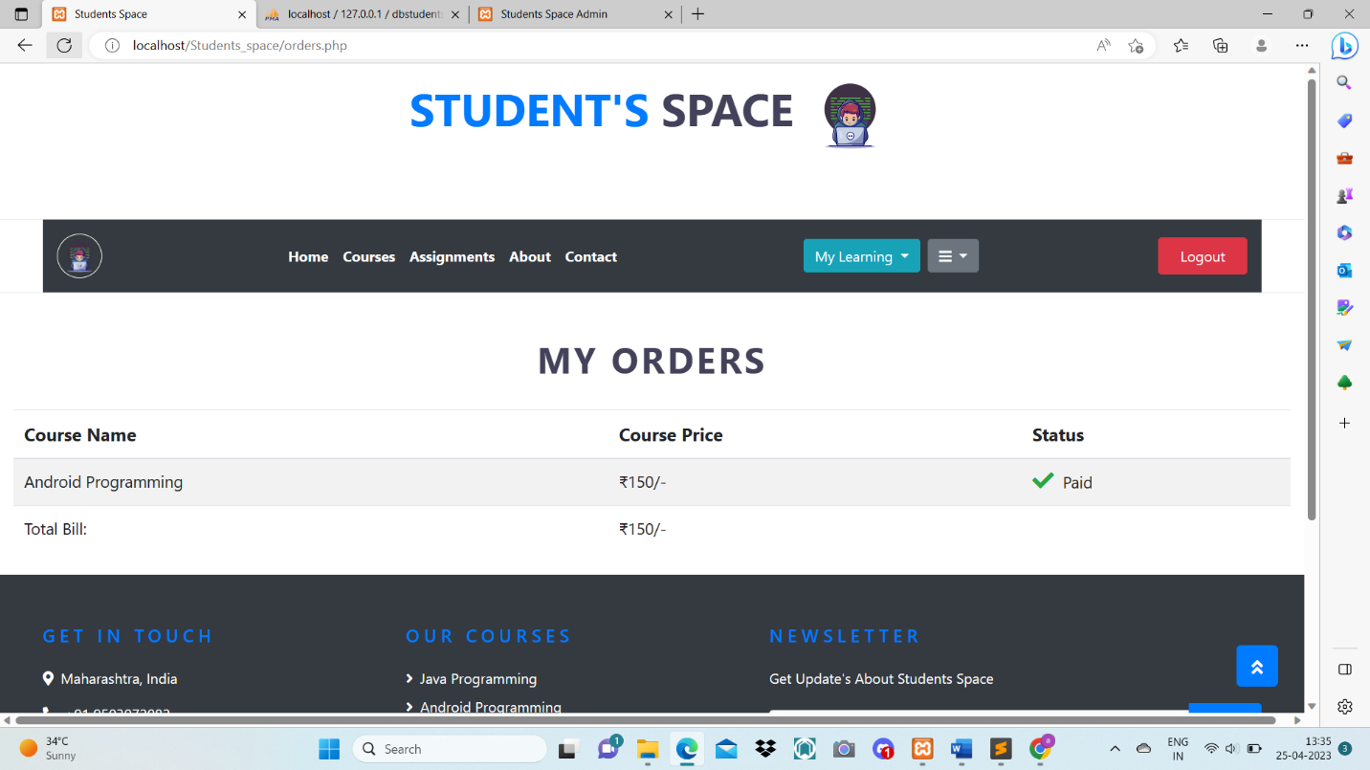

**Join Live Lecture:**

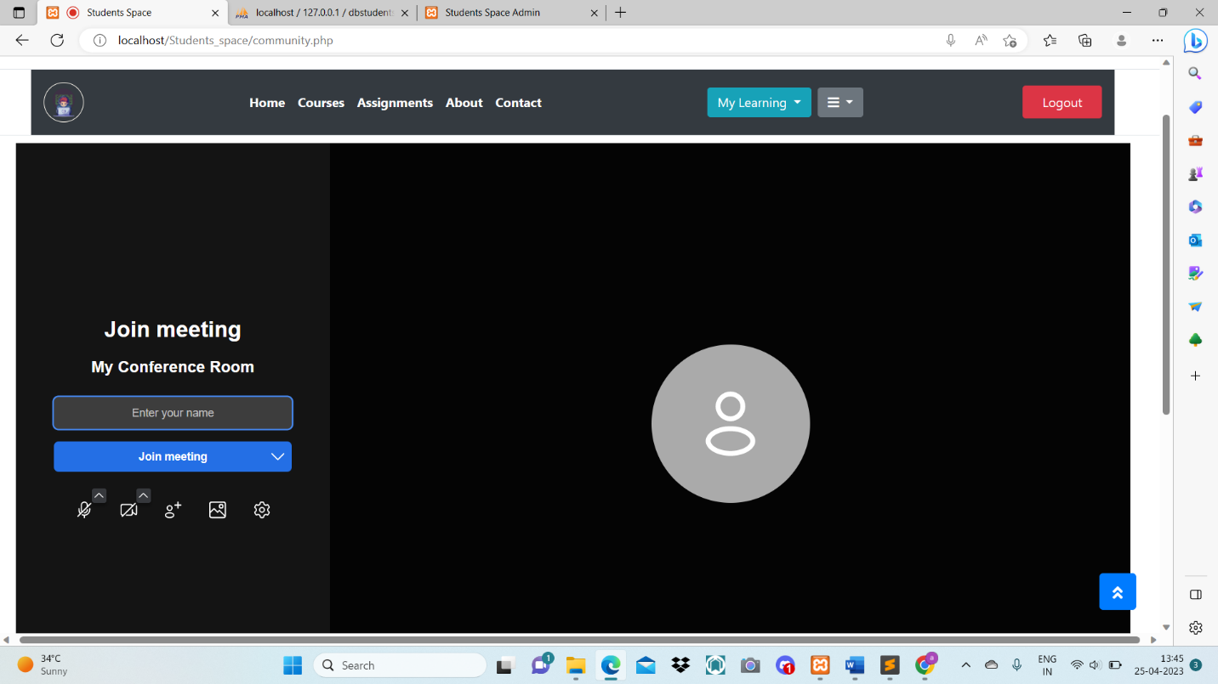

**Lectures Video:**

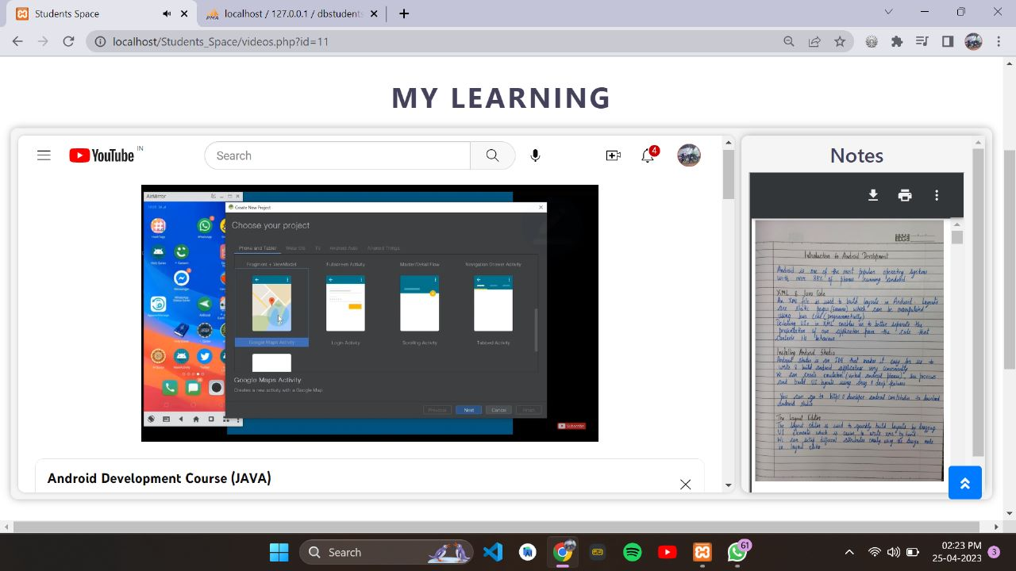

**Assignment session:**

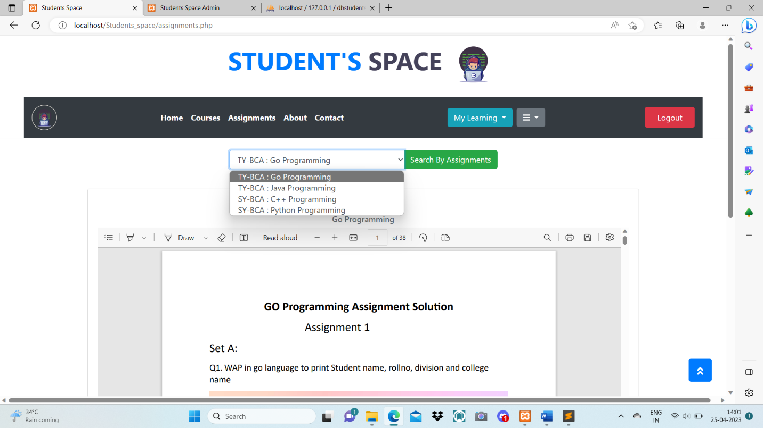

**Admin Panel:**

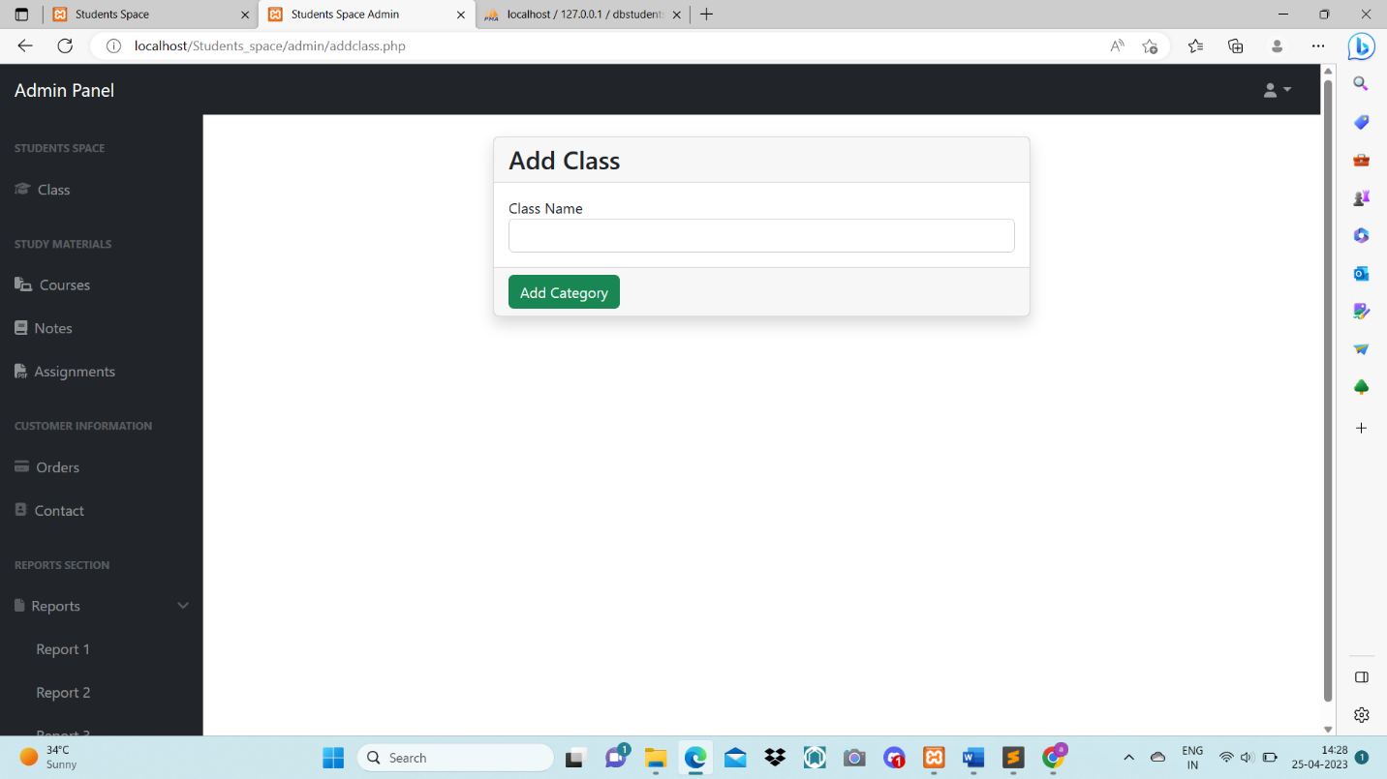

**Add Course :**

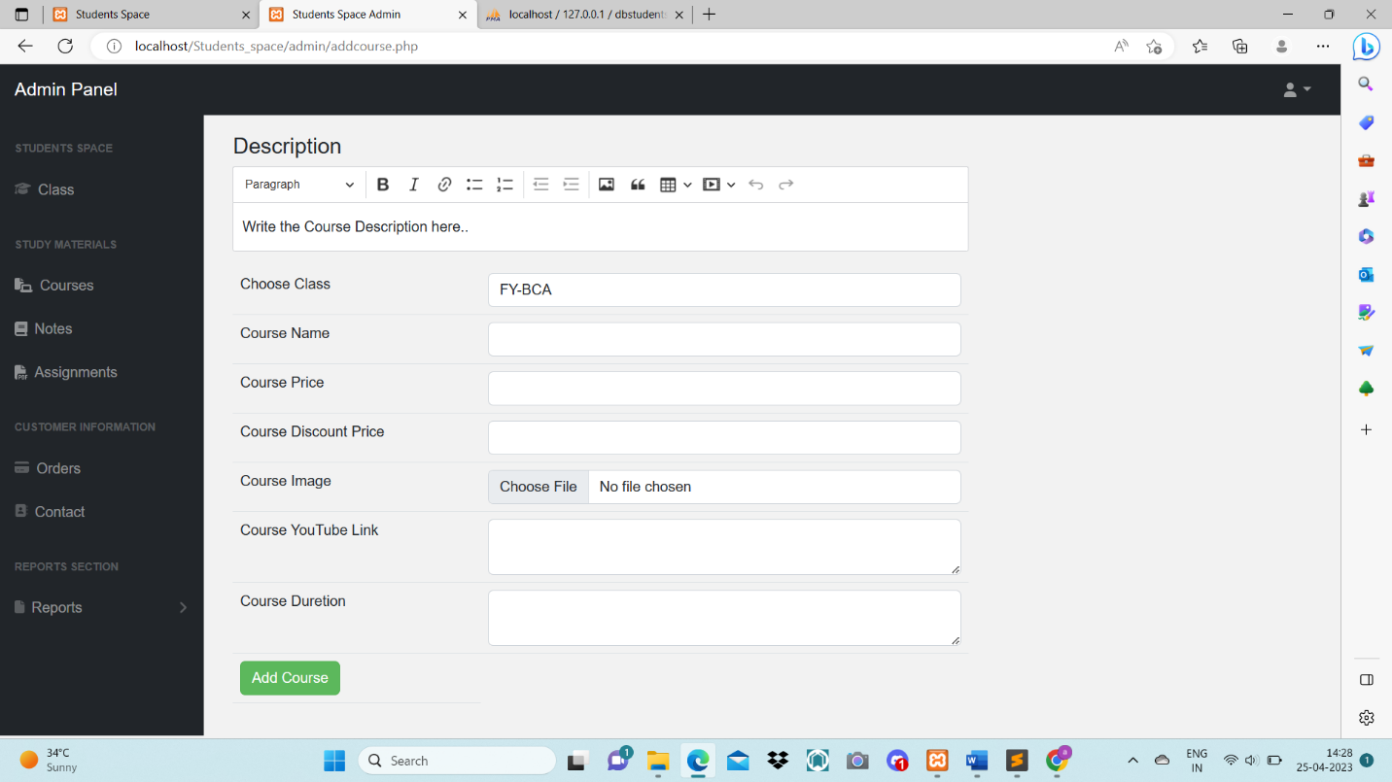

**Add Notes:**

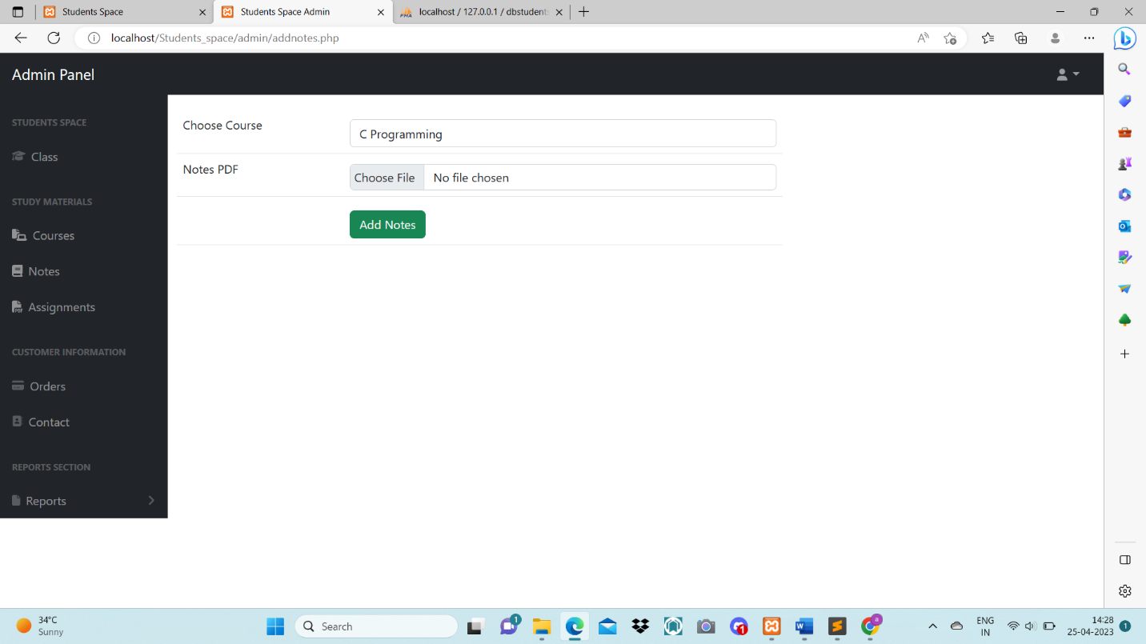

**Add Assignments:**

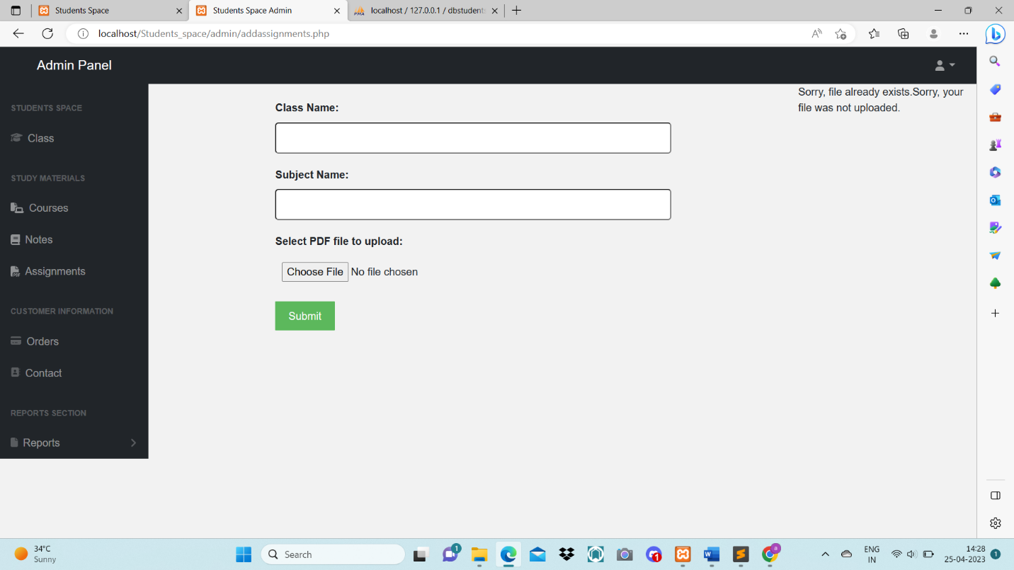

**Reports 1:**

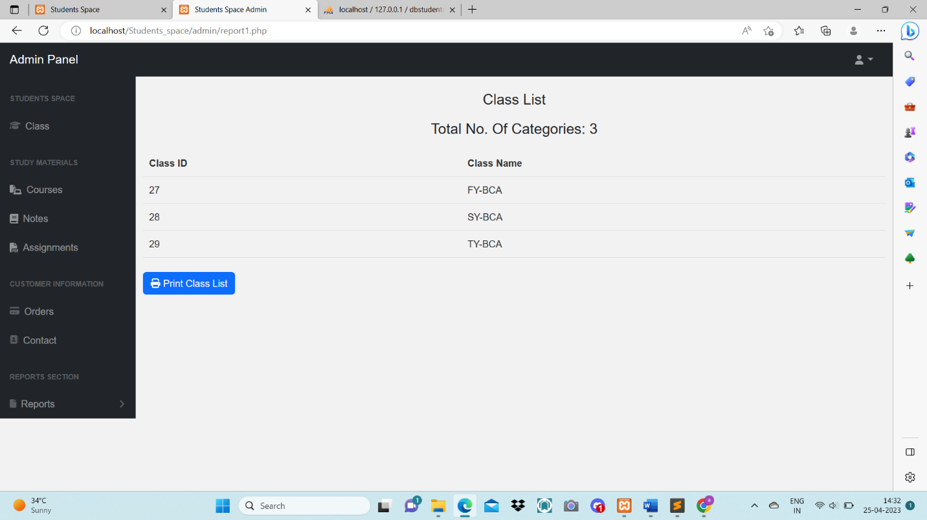

**Reports 2:**

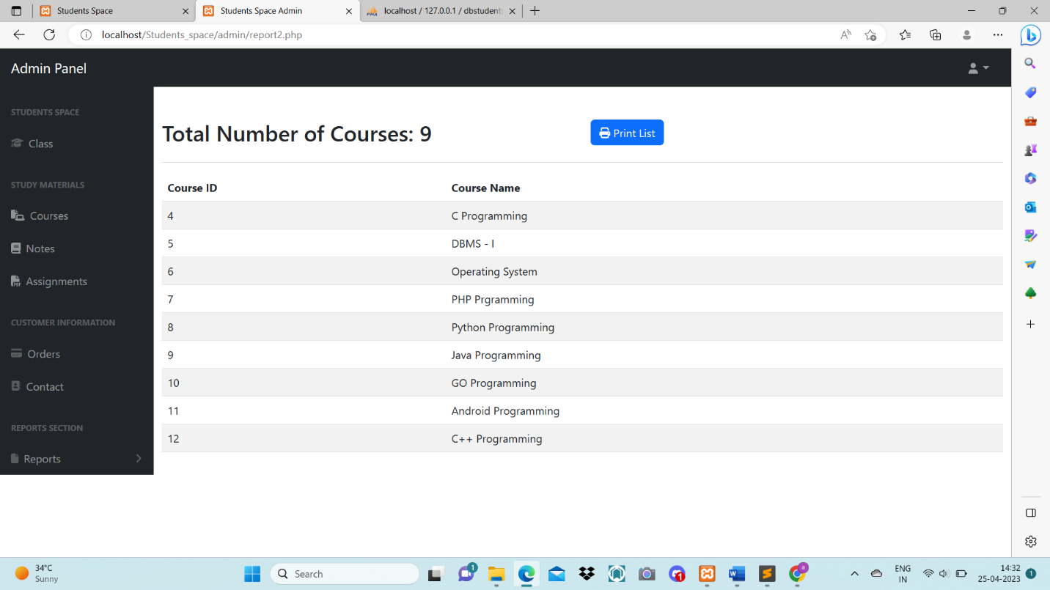

**Reports 3:**

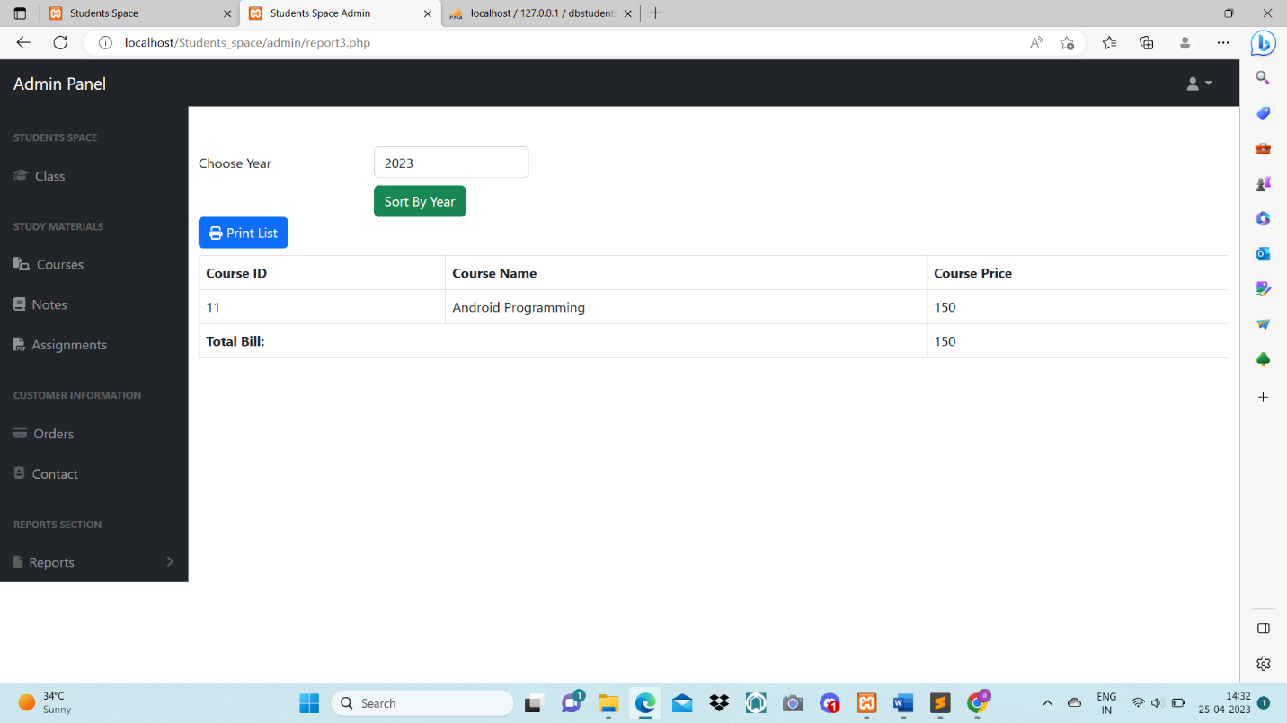

Limitation

• As we provide the best facilities for BCA students, there are limitations for students from other fields.

• Computer science courses such as B.E, B.Tech, BCA, and Bcs typically provide a common programming language that can be used by all students, but there are differences between the courses and each has its own quality for specific degrees.

• Limitations arise when it comes to assignment solutions, which may be different for different courses.

• The level of difficulty is another factor that varies among these courses. Therefore, the specialty for BCA students becomes a limitation for others.

CONCLUSION:

* BCA students work become more easier due to all provide all notes and assignment in one website.
* Data storage is done efficiently.
* Data retrieval is faster.
* Keeping a record of all entered was a very tedious job.
* Searching a particular entry was tedious because it involved searching all entries which required more time.
* The cost for maintenance is eliminated.
* Makes website user friendly.
* Our system provides two types of user administrator and local user which have a limited functionality. It improves the security.
* Only the admin who have administrative rights are allowed to create or modify users and unlock/lock users.

ADVANTAGES:

* Easy to access.
* Very user friendly to student.
* It is fast, efficient and understandable flow of content.
* Avoids data redundancy and inconsistency.
* Easy accessibility to data.
* Number of personal required is considerably less.
* Provides more security and integrity to data.

Bibliography

* + - [**http://www.google.com**](http://www.google.com)
    - **Learning PHP, MySQL & JavaScript-Robin Nixon**
    - **http://www.wikipedia.com**